L’art de représenter Le Roi Lear : approche textuelle et picturale.

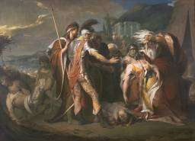

◄Fig.1 et 3
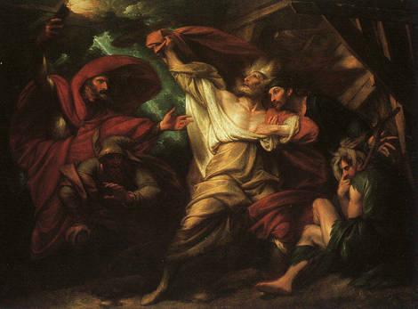
▼Fig. 2

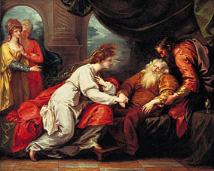

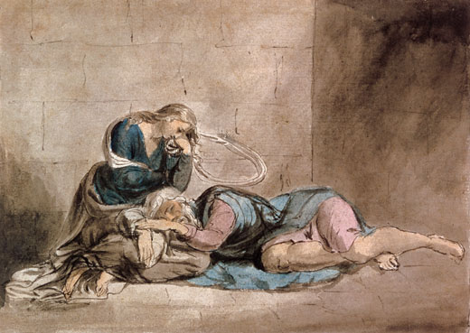

◄Fig. 4

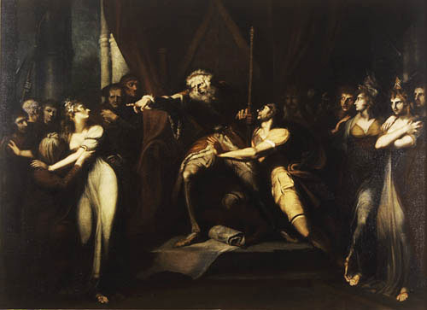

Fig. 6 ►

◄ Fig. 5
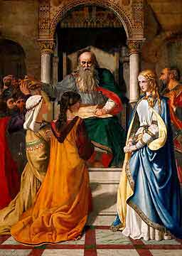

Fig.7 ►

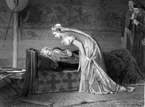
◄ Fig. 13 Fig. 14▼
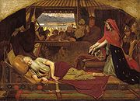

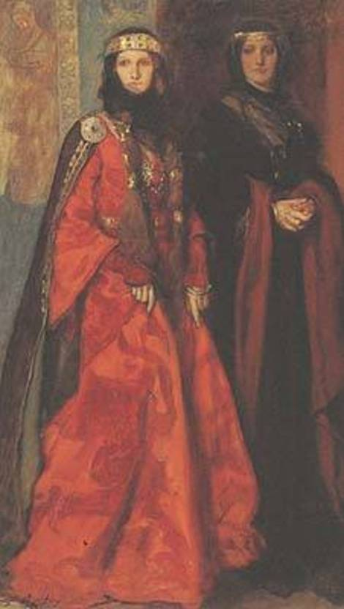


Fig. 15 ►

Fig. 16 ►

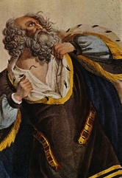

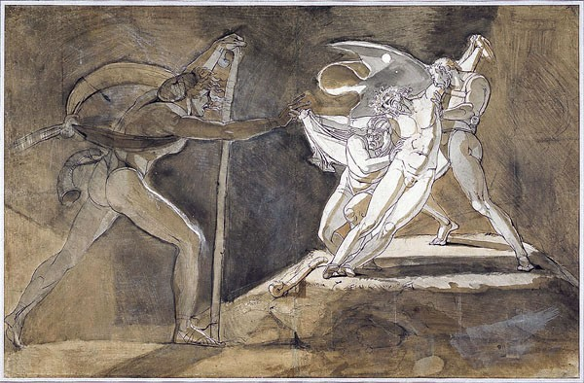
◄ Fig. 17

▲
Henry Fuseli, Edgar Feigning
Madness Approaching teh King
and the Fool, 1772.

Fig. 8▼
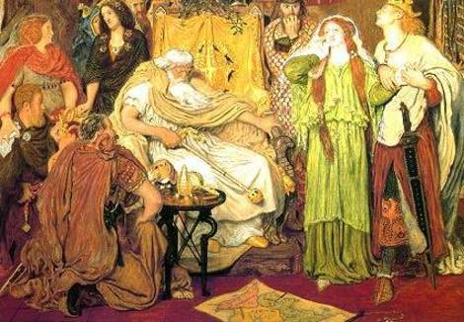
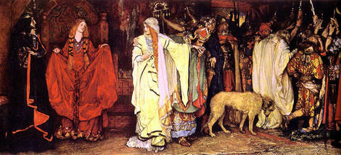

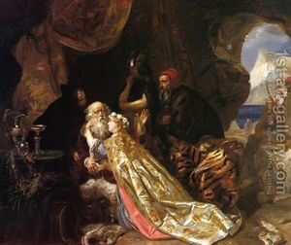

Fig. 9▼


Fig. 10▲

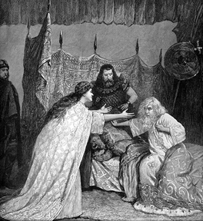
Fig. 11►

◄Fig. 12
« This is a detail from pages 616-17 (Volume 101) of
London Illustrated News, with a two-page engraving
showing the reconciliation of Lear and Cordelia in
Act IV, scene vii. With Irving is Ellen Terry, who
played the part of Cordelia.” Quoted from
http://www.english.emory.edu/classes/Shakespeare

